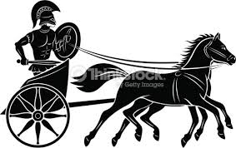
ANCIENT ROME GLOSSARY

TASK
Complete this glossary by giving definitions, examples and images to show your understanding

amphitheatre

aqueduct

Barbarian

centurion

century

chariot

citizen

civil war

consul

dictator

elite

Emperor

exile

forum

heir

legion

magistrates

market

mosaics

noble

omen

Opulence

orators

patricians

peasant

plebeian

province

republic

ritual

scholar

senate

slave

stola

tribune

viaduct

